

# PROYECTO:

“LO 1”

**REPORTE DE ACTIVIDAD PARA OBTENER EL TÍTULO DE:**

**INGENIERÍA EN TECNOLOGÍAS DE LA INFORMACIÓN**

**ÁREA DESARROLLO Y GESTIÓN DE SOFTWARE.**

**PRESENTA:**

**MAGDIEL ENRIQUE MEJÍA MARMOLEJO**

**CD. REYNOSA, TAMAULIPAS SEPTIEMBRE 2024.**

**Review of the Assigned Project**

The project consists of a device that allows the user to keep an accurate and detailed record of the detailed record of the merchandise he handles. This device provides valuable information that conventional shelf cannot provide, such as details on the dimensions, weight, date of registration or categorization of each item, just to mention a few, the date of registration or the categorization of each item, just to mention some of the advantages it offers.

This tool provides the user with a very efficient way for any business for any business that wishes to maintain a comprehensive and efficient control of its merchandise, improving both internal organization and merchandise, improving both internal organization and customer satisfaction.

**Justification of the Agile Methodology**

The project involves part of software and hardware that is the smart shelf and in the part of software the inventory management, Scrum’s approach to breaking down the project into smaller sprints allows us to build and test the product incrementally.

**Scrum Methodology**

**Reasons**

**Iterative Development:** The Smart Shelf System requires integration between hardware components and software processing, making it essential to develop in iterations. Scrum’s sprint-based approach allows us to break down the development into manageable increments, with each sprint focusing on building and delivering a specific feature (e.g., sensor integration, inventory UI, etc.).

**Handling Evolving Requirements:** As the system progresses, requirements might change based on user feedback or technical discoveries (e.g., adjustments in sensor accuracy or new inventory metrics). Scrum’s flexibility enables the team to adapt quickly to these changes, ensuring that the project remains aligned with stakeholders' needs.

**Stakeholder Engagement:** Regular sprint reviews will ensure frequent feedback from stakeholders such as warehouse managers or logistics personnel. Scrum facilitates consistent communication and adjustments, allowing the team to incorporate new insights or refinements as the project develops.

**Team Collaboration:** Scrum emphasizes cross-functional collaboration, which is critical for a project involving both hardware (smart shelf) and software (data processing, UI). Daily stand-ups and sprint planning will help keep the entire team synchronized on progress and potential challenges.

**Justification**

Scrum was selected for its ability to support the iterative and evolving nature of the Smart Shelf System. Its sprint-based structure allows us to deliver functional components frequently and adapt quickly to any changes or feedback. Collaboration across the team will ensure smooth integration between hardware and software, contributing to the overall success of the project.

**Software Architecture Justification**

**Layered Architecture**

**Modularity:** The Smart Shelf System is composed of distinct modules such as the data collection module (smart shelf sensors), processing module (backend logic for data analysis), and the presentation module (UI for displaying inventory information). A layered architecture allows for a clear separation of these concerns, with each layer handling specific functions, making development and maintenance easier.

**Maintainability:** By separating the system into distinct layers (e.g., data, logic, and presentation), future updates or changes can be made to one layer without affecting the others. This modularity simplifies adding new features or modifying existing ones, such as expanding the types of data the system tracks.

**Scalability:** The architecture supports scalability as new shelves are added, or more data needs to be processed. Scaling the data layer or adding additional processing power to the logic layer is straightforward without impacting the user interface or other components of the system.

**Security:** With a layered approach, security can be handled more effectively. For instance, the data layer can be designed to manage sensitive information like inventory quantities and access control, while the logic layer ensures data integrity during processing.

**Justification**

We selected a layered architecture for its modularity, maintainability, and scalability. This structure allows the Smart Shelf System to be developed and maintained efficiently, ensuring each layer can be updated or scaled without impacting the entire system. Security and performance can also be managed more effectively by isolating specific functions in their respective layers.

**Architecture Diagram**

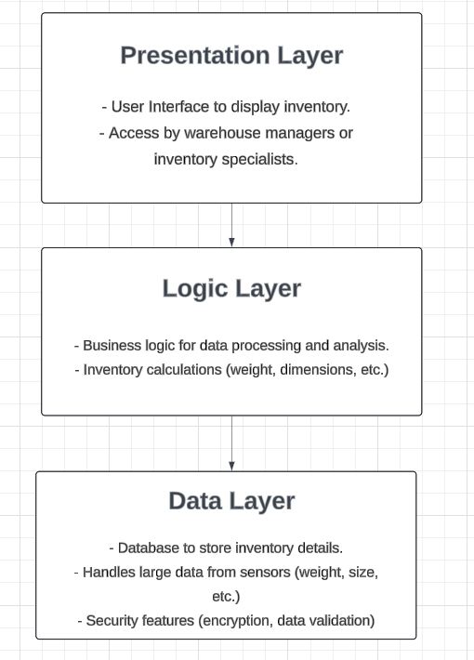

**Presentation Layer:** It is responsible for displaying inventory data to users in real time via web or mobile applications.

**Logic Layer: P**erforms the core business logic, processing the data received from the sensors (weight, dimensions) and making it ready for the presentation layer.

**Data Layer:** Manages the database and data storage, ensuring security, integrity, and access control over the system’s sensitive inventory data.

**Conclusion**

In conclusion, the scrum methodology and the layered architecture can help us to organize the work of the project and separate the different subjects of the project that can be easier to work and organize the workload. Also methodologies exists to help us to organizes our projects and teams to reach the goals of the project.